**PROJECT TITLE :** Scan a website using OWASP-ZAP Tool, to find the set of vulnerabilities and make a report on them.

**STEP-1 :** Choose vulnerability Website .

* Here, we are considering the website, <https://testfire.net>
* This is the picture of the browser showing this website:

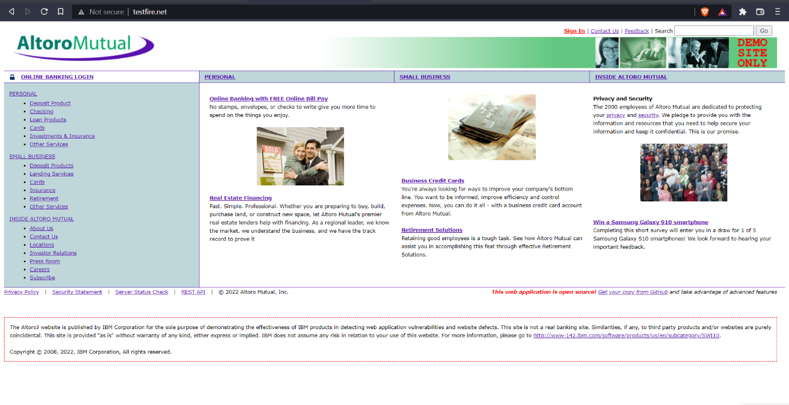

* Now, copy this URL

**STEP-2 :** Scan the website using OWASP-ZAP tool

* Open OWASP-ZAP tool
* Paste the URL –“URL to Attack : <https://testfire.net>”

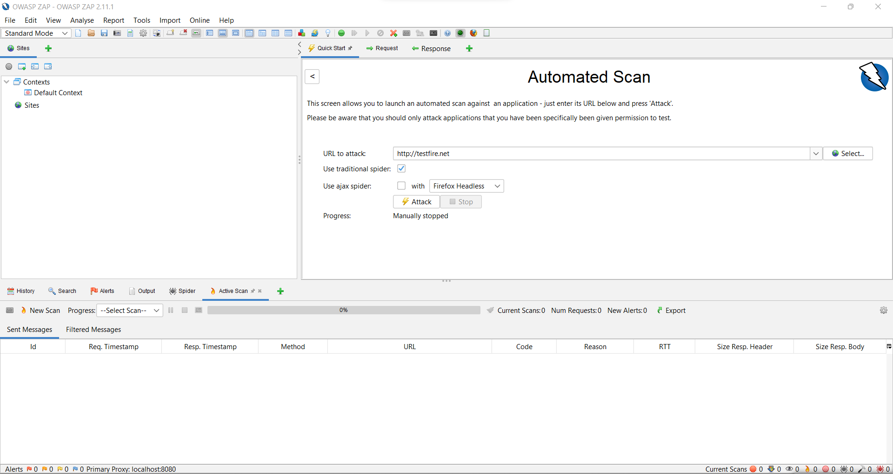

* Click on Attack
* Passive Scanning and Active Scanning occcurs

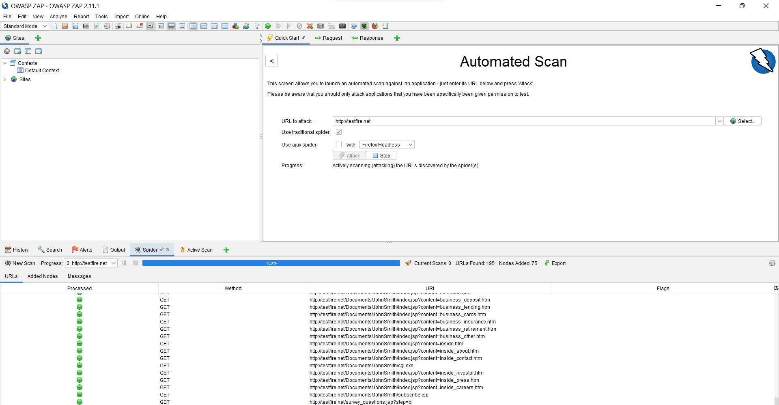

**STEP-3:** Report Generation

* Alerts are displayed when scanning is done 100%
* All the vulnerabilities of this website are shown here

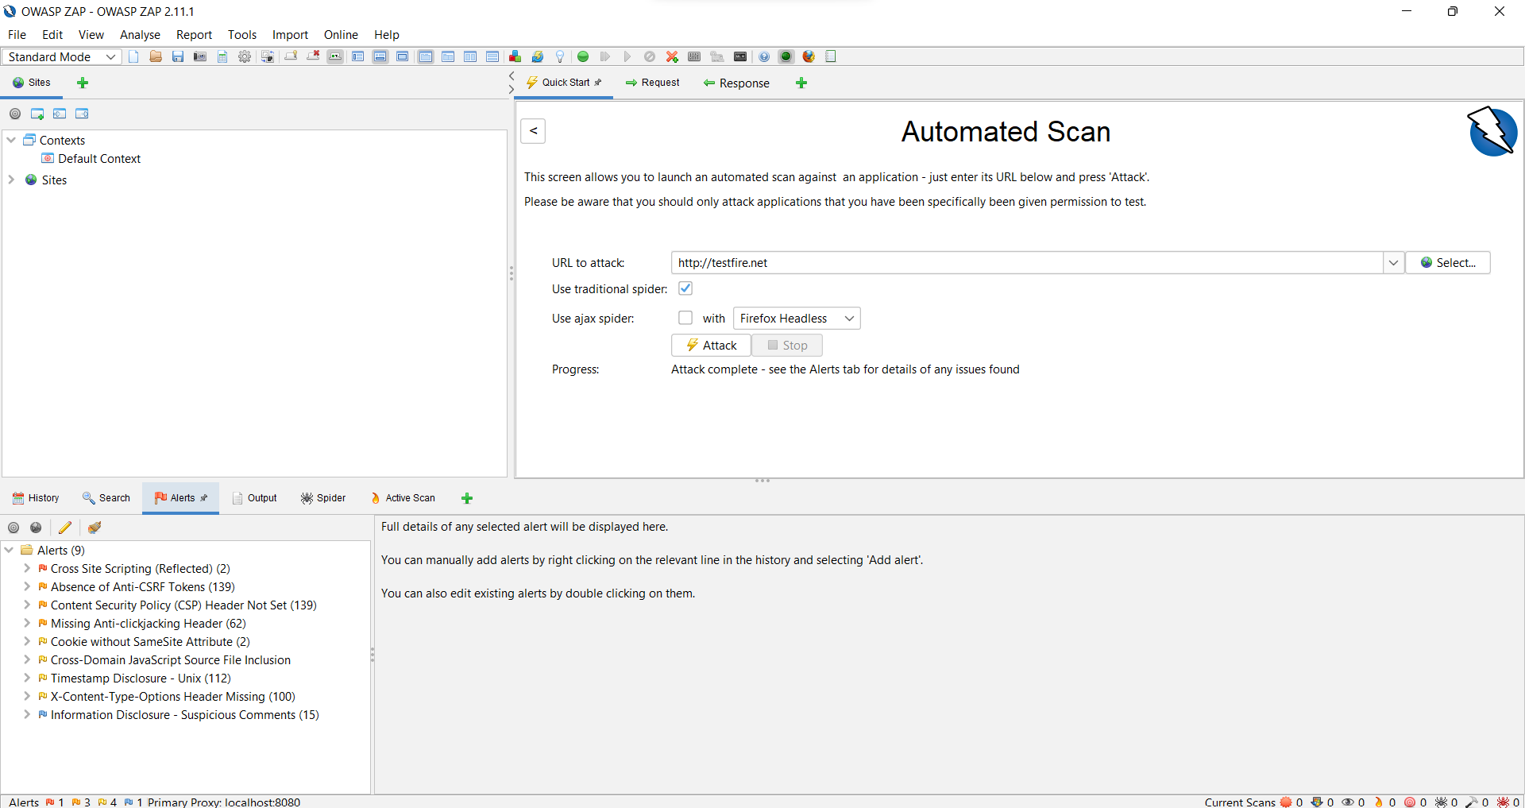

* Generate the HTML report from the Report Tool in the Menu bar.

